**MANUAL PRE-INITILIZATION**

Due to BYOB resetting the position of variables shown on screen when BYOB files are loaded (as well as personal laziness for making sprites that go with the scoreboard), some rather important variables are sometimes not placed in the proper places. In order to have the full experience when playing our new game, please follow these steps.

1. **BEFORE CLICKING THE GREEN FLAG,** show the *bestScore*, *score*, and *controlScheme* variables.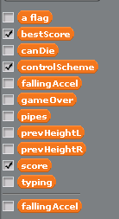
2. If you do **not** see the variables like this, you are free to continue. Otherwise, continue on.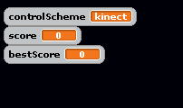
3. Go to the scoreboard sprite and run this code by left-clicking on it once.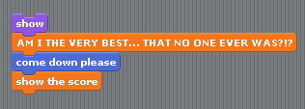
4. Move the variables into these positions, making sure that *bestScore* is at the bottom. To make the *score* and *bestScore* variables look like this, double-click the variable until it looks like below.

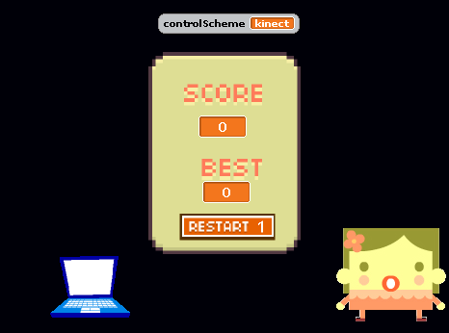

1. Once the variables look like this, you are good to go!

**HOW TO PLAY**

1. **PREFORM PRE-INITILIZATION**
2. Click the green flag.
3. Press the *c* key to toggle controls. Controls are defaulted as *Kinect Controls*, but *Keyboard Controls* are also available.
4. Watch the intro scene.
5. **PLAY THE GAME**
   1. *Kinect Controls*
      1. Flap arms to go up.
         1. The harder you flap, the higher you go!
      2. Keep arms up after flapping in order to fall at a **slower** speed.
      3. Bring your hands in to fall at a much **faster** rate.
   2. *Keyboard Controls*
      1. Press *space* to fly.
   3. Passing a pipe gains one point.
   4. **FAILING**
      1. **Causes of Failure**
         1. Flying too High
         2. Hitting the Floor
         3. Hitting a Pipe
      2. The game ends. You see your score and best score. The game restarts automatically after three seconds.

**HOW DO I CHEAT?**

Are you sure?

No, seriously. Are you **SURE**?

You do know that your bird will **SCREAM** ***“CHEAT CODE UNLOCKED!!!”***

OK, fine.

Inputting the following key combination will result in the bird being unable to die.

↑↑↓↓←→←→

Did it work? No? Well then, try pausing the game with the yellow pause button and then enter it.

Inputting the same key combo will allow you to score one extra point.

You still want more cheats? An extra 10, 100 points? Changing the background *(*[*#google-hangouts*](http://abcnews.go.com/blogs/technology/2013/05/make-ponies-and-dinosaurs-dance-across-your-google-hangouts-chats/)*)*? Stopping the infamous *Kinect Input Lag*? The *Cheats Pack* is now available at the EA Games Store for $99.99! Great Value! *(*[*#reference*](http://www.androidpolice.com/2014/01/31/nerd3-goes-on-an-epic-rant-about-dungeon-keeper-and-its-70-microtransactions-video/) (**WARNING:** explicit video on page), [*#reference1*](http://www.geek.com/games/ea-expects-to-earn-1-billion-from-dlc-this-year-1602935/)*)* *(****NOTE:*** *in this manual, hashtags = the reason for why things are partially funny… in my opinion :P. Please click them if you want to.)*